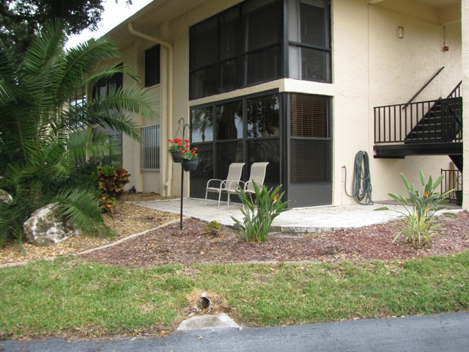  View from Southwest corner | 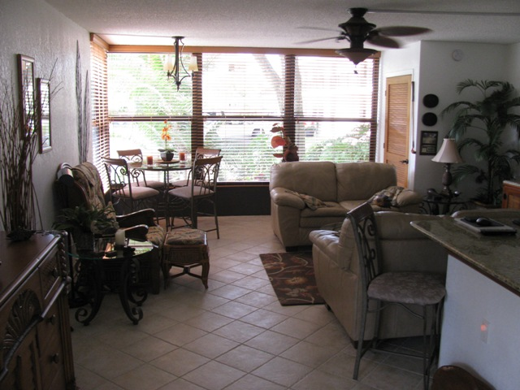  Living Room from entry door
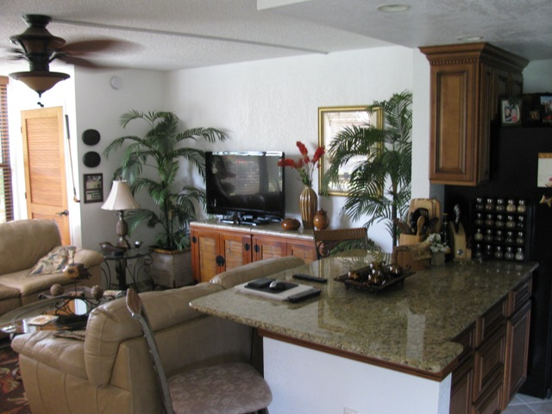  Kitchen counter and LR from entry door | 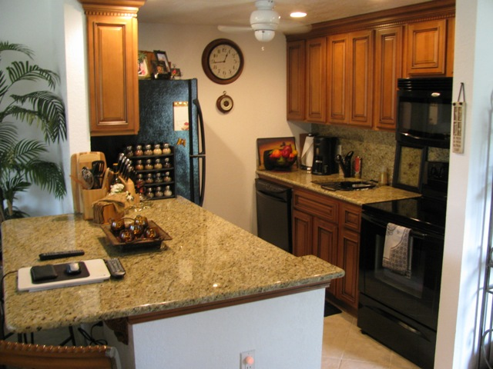  Kitchen
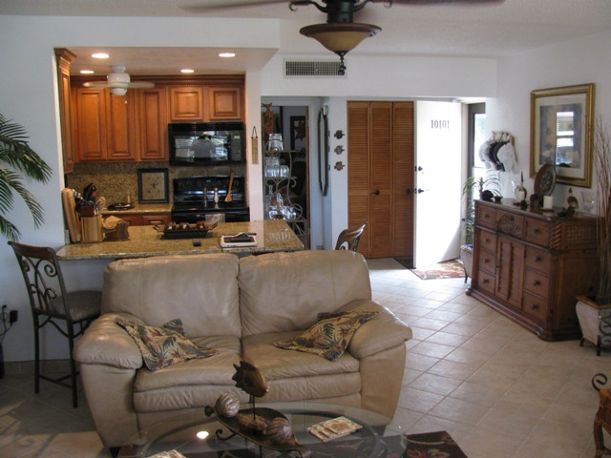  Kitchen and entry from LR | 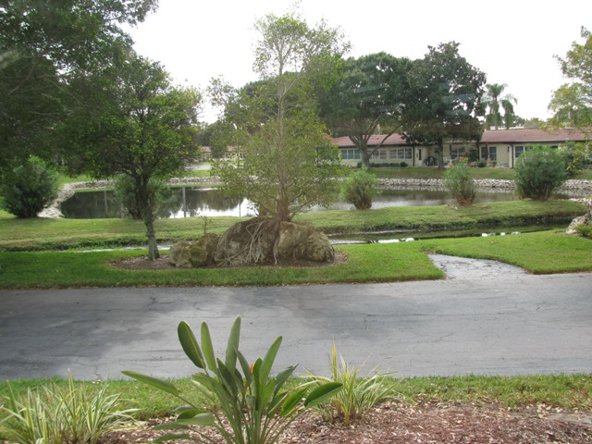  North view from SW corner of LR
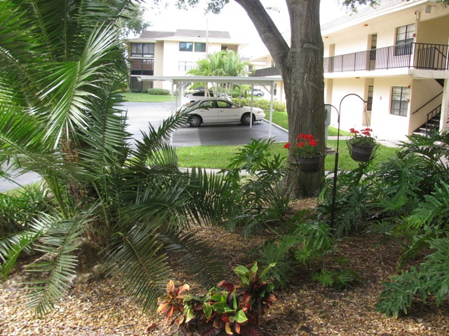  View to the West | 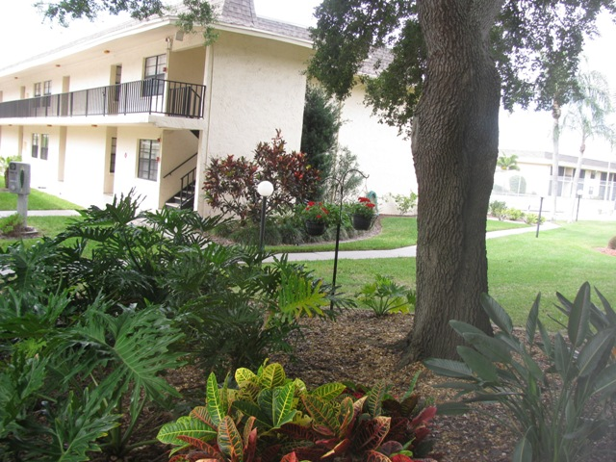  View to the West
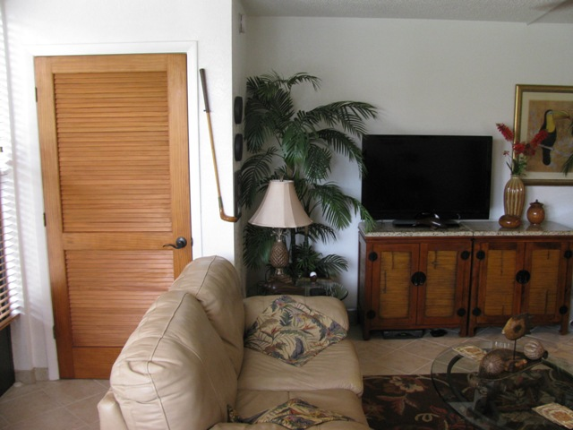  LR view of NW corner closet | 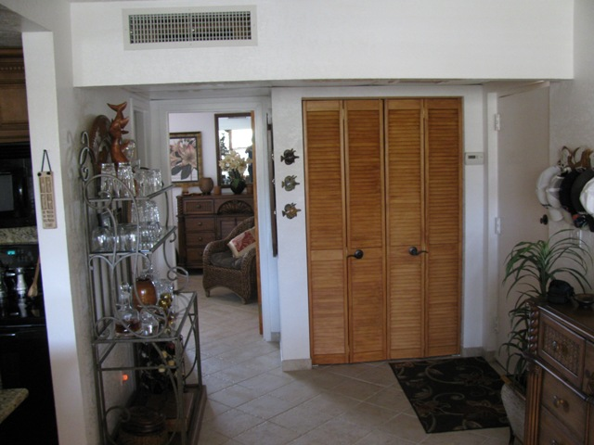  View from LR of closet and BR
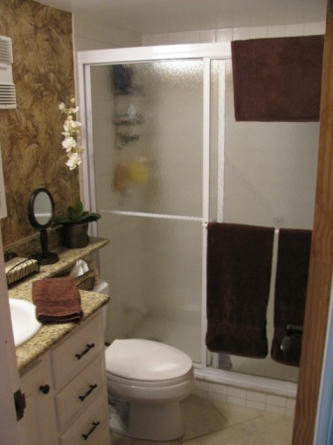  Bathroom | 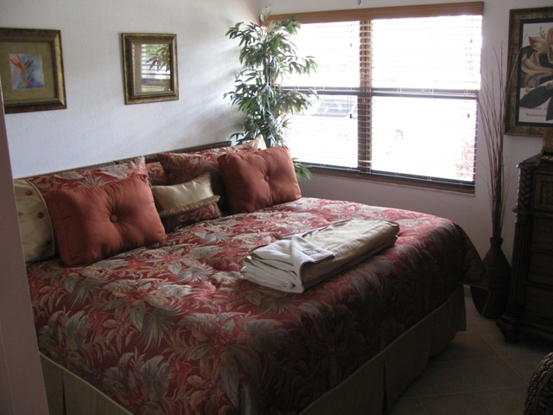  Bedroom
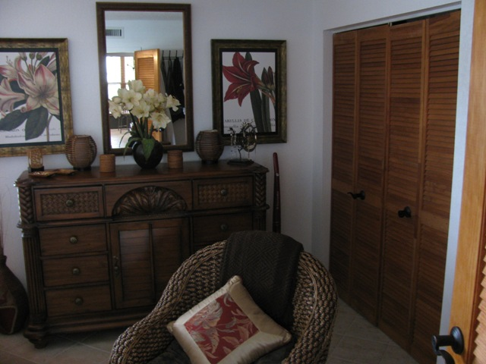  Bedroom | 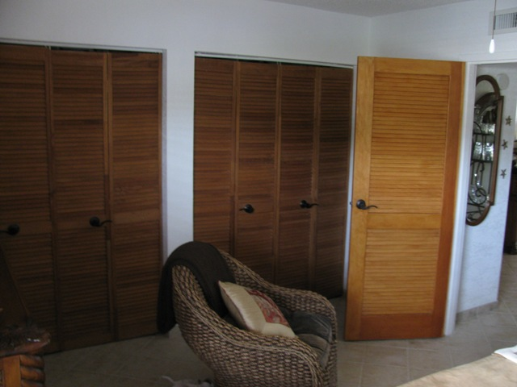  Bedroom closets
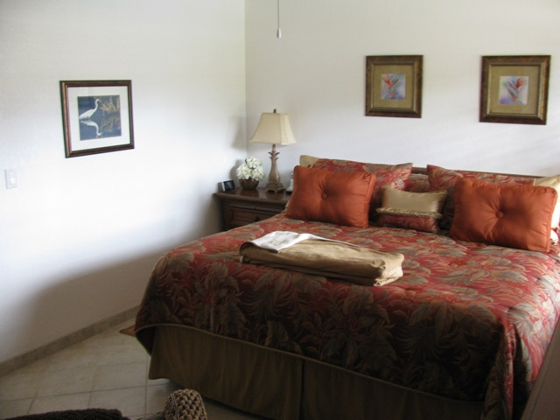  Bedroom | This 1st floor end unit in Bldg 10 is fully renovated with top of the line materials and furniture.  The kitchen has been expanded with a sit down counter top. The LR has been extended to eliminate the porch area for a beautiful viewing area of the grounds.  Most of the furniture is included.  Contact for viewing 727-517-9166 or 727-385-8030

